**TikTok Project A report**



| **Project Group** | | |
| --- | --- | --- |
| **No.** | **Name** | **Email** |
| 1 | James | s10204693@connect.np.edu.sg |
| 2 | Louwen | s10202923@connect.np.edu.sg |
| 3 | Alan | 211384u@mymail.nyp.edu.sg |
| 4 | Ong Yu Xun | 2102029@sit.singaporetech.edu.sg |

**Project timeline:**

Based on the discussion that we have within our team, we decided to do Project A within 3 days after the project explanation is given. Afterwards, our plan was to start working on the project after all the lessons have ended. We have decided to split the project into 2 parts, the front-end and the back-end. Some of us are stronger in the front-end while others are stronger in the back-end. So with that we split our workload accordingly. Though we wanted to start early, because of our individual busy schedules, we ended up starting later than what we had planned for.

**Work allocation:**

| **Name** | **Work allocated** |
| --- | --- |
| James | * Front-end Design for HangMan Game |
| Louwen | * Front-end Design for HangMan Game |
| Alan | * Backend logic for the HangMan Game |
| Ong Yu Xun | * Report |

**Technical:**

For our project, we used HTML, CSS and javascript to create the Hangman game website

| var lives = 6  var list;  var currentLives;  localStorage.setItem("myLives", lives);  function updateLife()  {  if (localStorage.getItem("mylives") > 0 )  {  lives - 1;  document.getElementById(mylives).innerHTML(currentLives);  }  else  {  document.getElementById(mylives).innerHTML(currentLives);  alert('Game Over, You lost')  }    } |
| --- |

For our project, we found that implementing local storage was most useful when it came to updating the player’s life

**Project:**

* Github link:

https://github.com/stopscratchingtables/tiktokcampprojA

* Key screenshots (in different screen resolution)

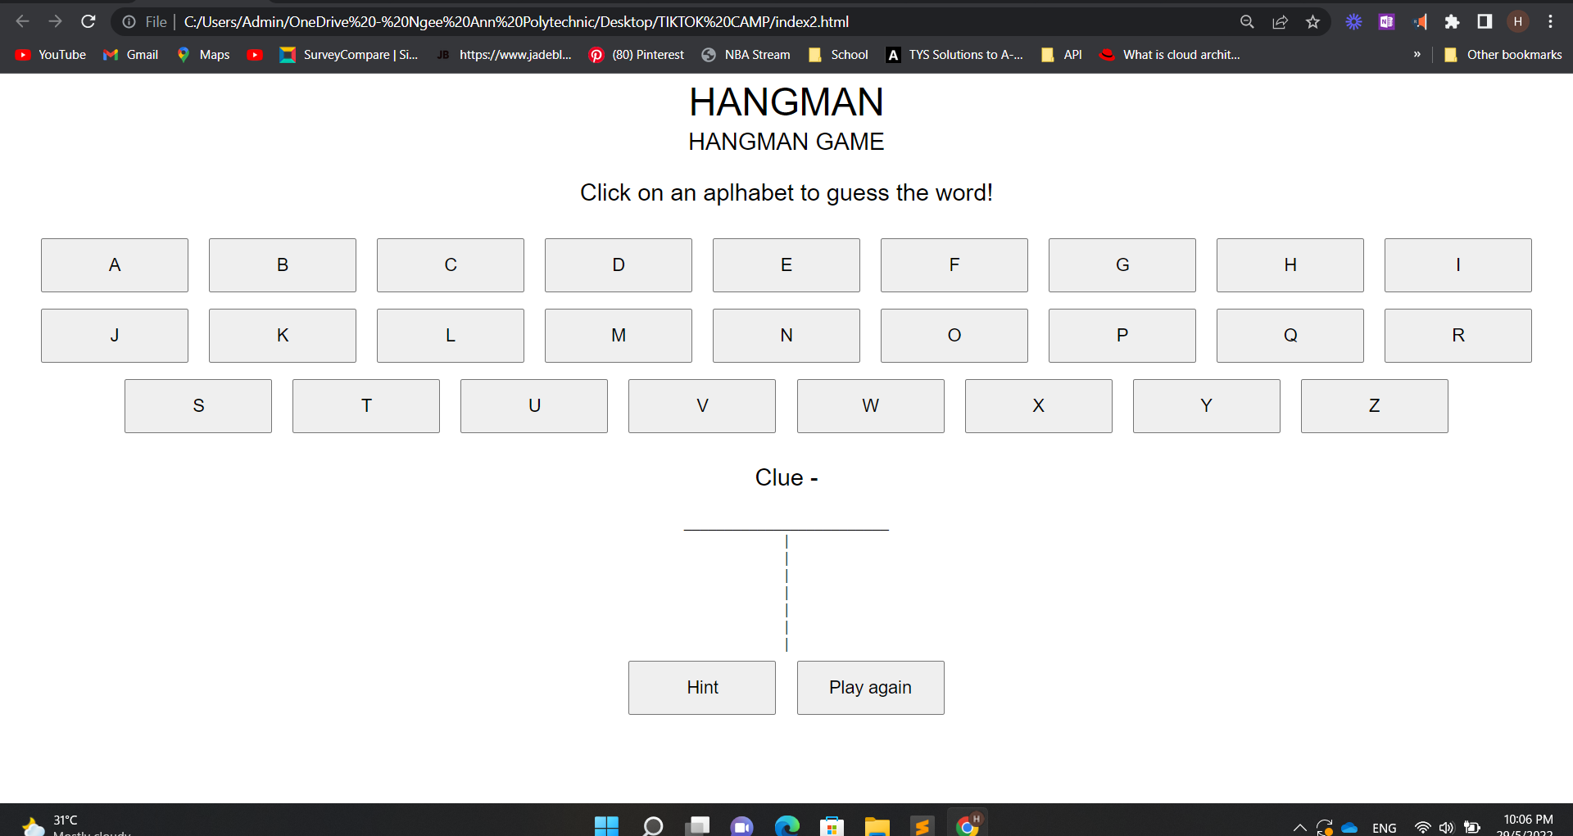

**Project Retrospective:**

What we think went well was that the project itself was done and that even though it was rather rushed, yet we managed to complete it and hit all the basic requirements. And individually, we just took up the individual role to do what we can do so that we can still complete our project on time.

What could be improved is that we can better manage our time and to start early as it is according to our plan. Despite our difference in schedules and busyness, starting at the time we have planned would be a rather comfortable pace for each and everyone of us to complete the project. But because of the delay, we ended up rushing to complete the project.

What we would commit to improve in the next project is to keep to our plan that we have and to have better communication with one another and set aside time and to plan ahead so that we can still gather together and discuss our project and to complete our project with a comfortable pace which we would all be comfortable with.